CSE 581

**Lab 13: Functions**

*Do this against YOUR own database.*

***For the entire lab, provide all of your SQL as text, inserted at the beginning of the document.***

***For each step also provide a screenshot of execution, showing the SQL and the results.***

***Please make sure both the SQL and the screenshots are marked w/ the question number that they are answering.***

**Steps:**

1. Create a function that will accept CourseId and Numerical Grade and will calculate the letter grade. The function will return the appropriate *Letter Grade Description* based on the input and the ***Course Grading*** table[1][2].

CREATE FUNCTION dbo.Cal_LetterGrade (@CourseId as integer, @NumericalGrade as decimal(5,2))

RETURNS varchar(100) as

BEGIN

DECLARE @LetterGradeDescription VARCHAR(100)

SELECT @LetterGradeDescription = (SELECT TOP 1 Description from lettergrades

inner join coursegrade

on LetterGrades.LetterGradeId = CourseGrade.LetterGradeId

where @CourseId = CourseId AND (@NumericalGrade >= GradeValue ))

return @LetterGradeDescription

END;

select LetterGradeDescription = dbo.Cal_LetterGrade(1,95);

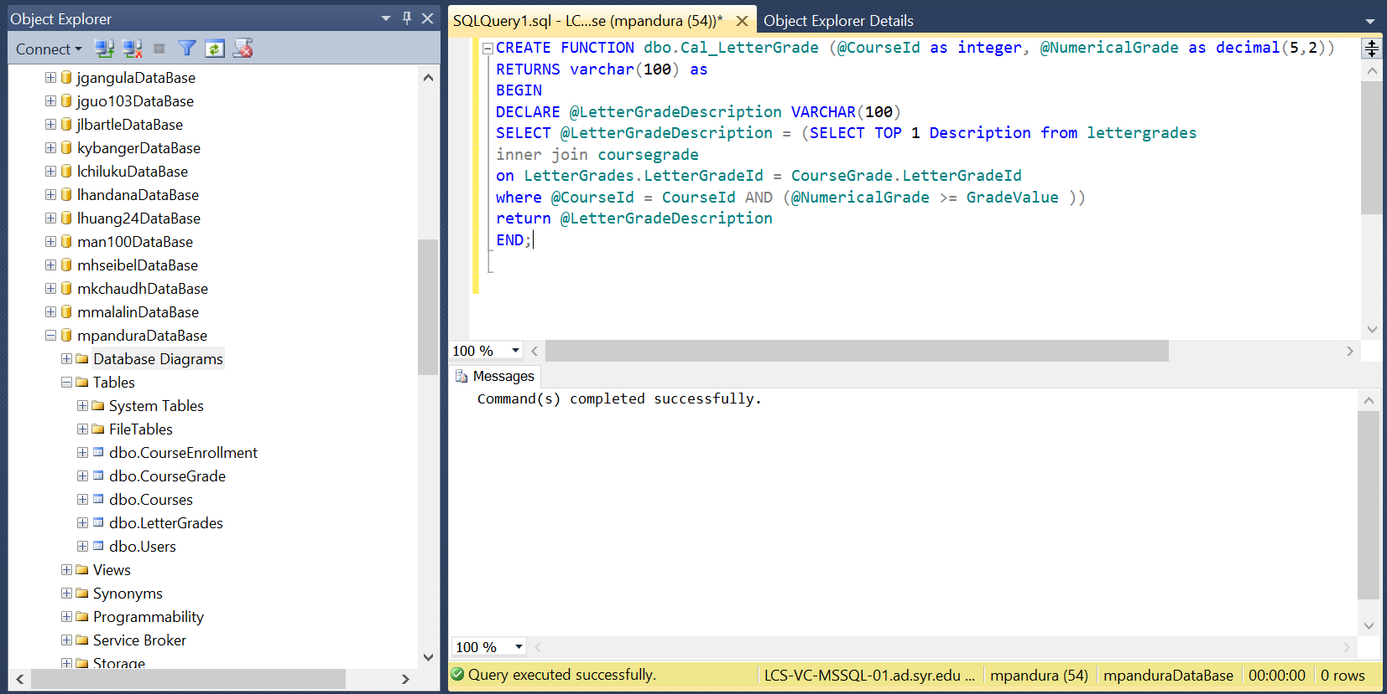

1. Verify that the function works as expected:
   1. Run the function for the CourseId = 1, NumericalGrade = 95.

select LetterGradeDescription = dbo.Cal_LetterGrade(1,95);

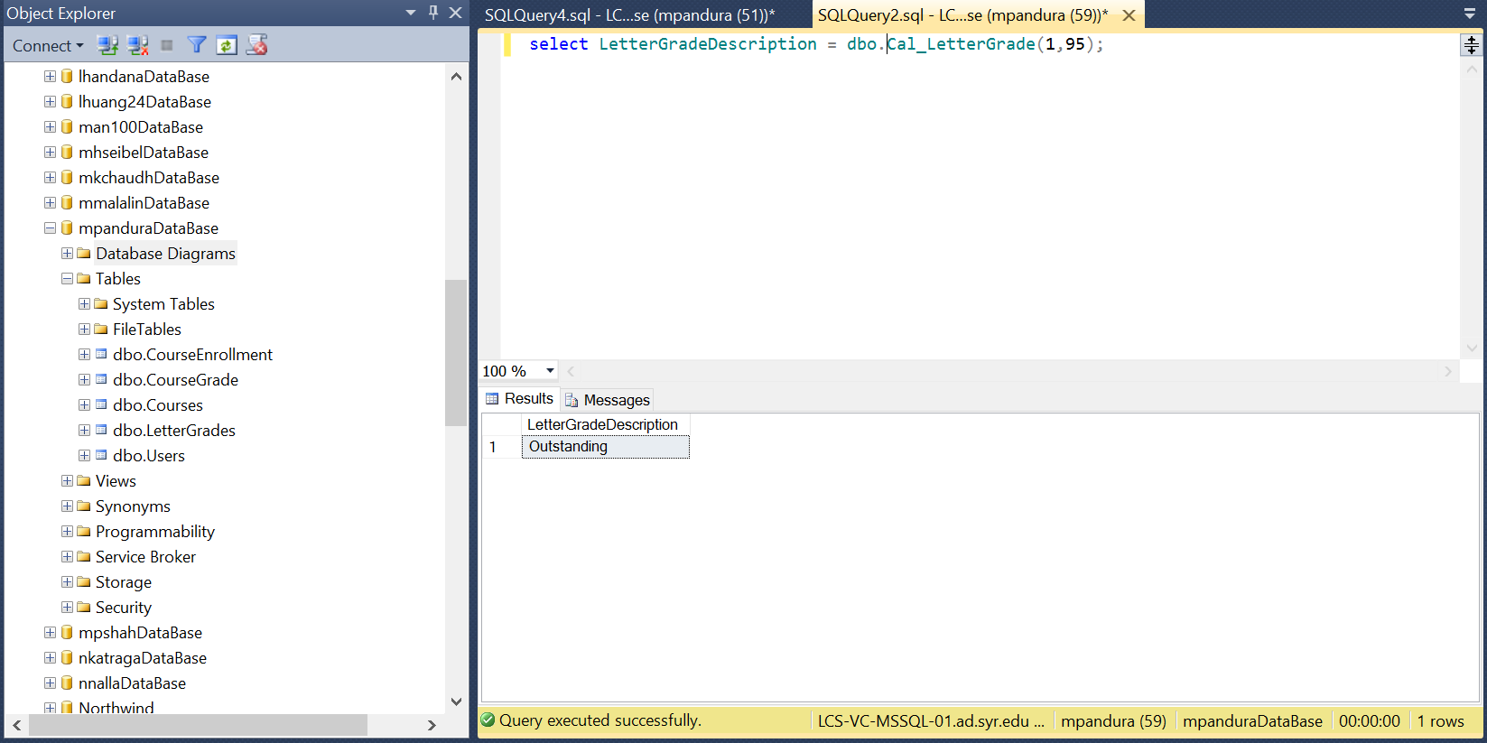

* 1. Run the function for the CourseId = 2, NumericalGrade = 95.

select LetterGradeDescription = dbo.Cal_LetterGrade(2,95);

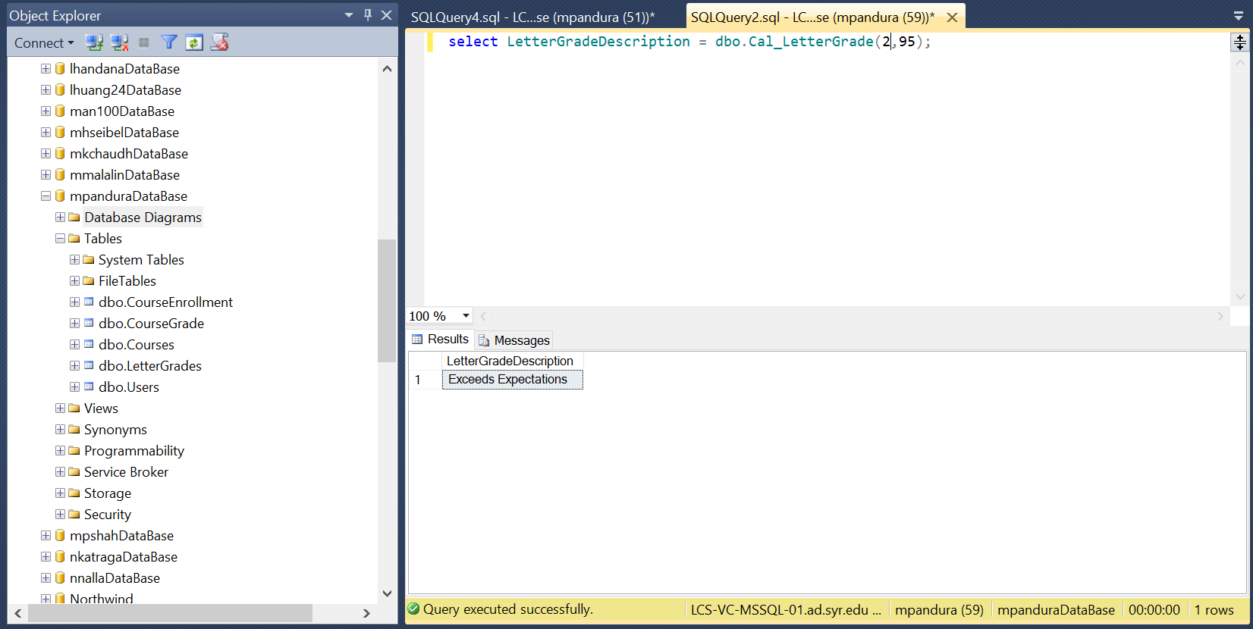

* 1. Run the function for the CourseId = 2, NumericalGrade = 85.

select LetterGradeDescription = dbo.Cal_LetterGrade(2,85);

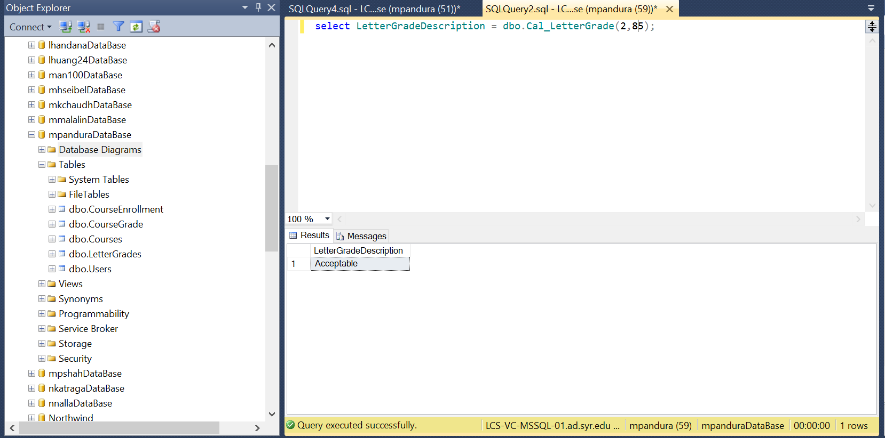

1. Please consider how grades are calculated. For example, if 90-92.9 is an A-, and you get a 92, then you get an A-.
2. Please do not hardcode values into your function. Use the table to make the decisions. **If you hardcode the values, you will lose 60% of your grade.**